
Shopping Design Q1 2021 QBR

1. Overview
The purpose of this document is to summarize Shopping Design’s Q1 highlights, lowlights, hotly debated topics and program updates. This doc will emphasize where the Shopping Design organization is driving unique value and innovation across the customer journey, with the overall objective of eliciting meaningful CX discussion, debate, and decisions on the end-to-end shopping experience and the programs and mechanisms supporting it.

2. Charter
The Shopping Design team includes designers, researchers, technologists, writers, program and product managers who design the shopping experience worldwide. We own the features that enable customers to discover, evaluate, and transact on Amazon and are stewards of the end-to-end shopping experience, ensuring the 300+ shopping designers outside of our organization (and thousands of tech resources) have design patterns, systems, tools, customer insights and best practices to design a cohesive and delightful shopping CX. We drive awareness, adoption, and mastery of working backwards from customer needs through programs including CXBR, Inclusive CX, Shopper Frustrations and Continuous Innovation. Our mission is to design an extraordinarily fun and easy shopping experience that customers love and can’t live without.

3. Highlights
3.1 We launched the new Amazon shopping app icon to customers worldwide. As of 1-Mar, the new Amazon shopping app icon was launched on iOS and Android devices worldwide. Our goal was to design an icon that encapsulated the Amazon shopping experience at a glance. The primary focal point is the Amazon ‘Smile’ in a craft brown delivery box with a pop of blue packing tape. This design sets it apart from other Amazon apps and retail apps, evoking the moment of joy when customers receive their Amazon delivery. We conducted a survey in US, DE, FR, JP, BR (n=4,500) to evaluate design likability and perception, then ran two US-based studies with customers to understand icon usability and findability (n=400). We launched in UK/IT/ES to gather customer input before launching worldwide. We saw both positive and negative customer reactions via social media. Before launching WW, we made the tape more obvious to avoid any customer confusion. Press and customers took notice of this pivot; including an article in Inc. Magazine which said listening to customers and improving the design was “a great example of emotional intelligence”. Two weeks following the launch, Daily Average Usage (DAU) metric was +Tk% WW on Android and +Tk% WW on iOS against the trailing 4-week average. This was a momentous launch as the icon has not been updated for Tk years and is the first time we are using the same icon design in all locales. Several teams came together to make this happen, including early alignment with XCM on brand fit, leadership inputs into the roll-out strategy, and launch support from Release Engineering, Mobile Marketing and PR teams.
3.2 We launched a new partnership model for Homepage Design. In Feb 2021, we launched Project Ranger, an initiative that evolves Homepage Design’s role with strategic partners from gatekeeping to collaboration. In 2020, we manually reviewed Tk assets from Tk+ partner teams, reviewing individual campaign creative days before launch on site. The process was cumbersome, with long SLAs, and churn from escalations and exceptions. Ranger upends this model by moving individual asset reviews back to partner teams, focusing our influence on monthly 1:1 consultations, collaborative testing plans, customized guidelines, and targeted quality audits. Phase 1 (15-Feb to 15-Jun) launched with three pilot teams: Music, Fashion, and Fresh. Initial response was positive, with the Head of Creative Studio for Music sharing that the project “distills the value of the Homepage team while enabling business to own their own content.” Mid-way through Phase 1, we have partnered with Ranger teams to identify Tk design experiments, and we estimate Tk assets/month will move to Ranger self-moderation. Early campaign data shows increased customer engagement under Ranger guidelines: Fashion editorial campaigns submitted through Project Ranger (from 15-Feb to 15-Mar) generated TkM clicks (+Tk% YoY) and a Tk% CTR (+Tk bps YoY). We will expand Project Ranger to an additional three teams by EOY 2021.

3.3 We designed an Inline Twister experience so customers can expand and select product dimensions without leaving Detail Page. On 22-Feb, BuyX launched a new mobile Inline Twister experience for ASINs with 3 or more product dimensions, after a $TkMM annualized GCCP Weblab win. This new experience is based on a design visioning exercise from 2018, where the design team took inputs and requests from category partners and created a future version of Twister that would scale across categories, from running shoes to configuring a new car. We’ve since refined the experience to solve 3 long standing customer frustrations around price/variation discoverability, thumbnails being too small to inform a purchasing decision, and an inability to easily compare multiple options. Customers can now take advantage of larger product thumbnails, compare price for each variation, and view all product dimensions inline using an accordion flow, without leaving the context of the Detail Page. With the success of our inline design concept, customers now get a consistent experience for 1, 2, and 3+ dimensions. Desktop UX design is complete and dial-up is planned in Q3.

3.4 We designed a new Mobile homepage hero and personalized content experience. We redesigned the top of page experience to better greet the customer, with a taller hero and a set of personalized cards to help guide the shopping experience. After a weblab in Fall 2020, we saw a drop in hero impressions and Deals revenue, and hypothesized a multi-slide “Herofader” would help solve this. In addition, we used this as an opportunity to bring Deals into the personalized cards experience. In January 2021, we conducted research and learned that customers intuitively interacted with both the hero and cards area. We then collaborated with teams worldwide to prepare for a dial-up 2-Feb. We launched the new design after Weblab experimentation ran in [countries] and yielded positive results of $TkC-OPS (Tk% PPR), $TkMM CCP (Tk% PPR), and $TkMM GCCP (100% PPR). This new experience will roll out to all locales by 03-May except IN, who observed an annualized decrease in NPX purchase days ($TkMM, Tk% PPR) caused by reduced engagement with Amazon Pay (launch targeted for after Prime Day 2021). Results for unrecognized experience were negative: -$TkMM GCCP (0% PPR). Our hypothesis is this is poor performance of the sign in card as a dashboard card instead of the larger full-width card in control. We will test new treatments for the sign in card in Q2.
3.5 We launched the AUI+Rio documentation site. On 28-Apr we launched the new AUI+Rio docsite as the single source of truth for design and development, offering accurate and up-to-date guidance on how to use and implement AUI components. This replaces the old AUI and HIG/Sky design sites, which were out-of-sync, and directs traffic to the unified site. Shopping Design led technical architecture, using internal and native services to create an automatic deployment system in order to make contribution simple without requiring development support. The docsite uses Lego CMS for authoring static content that deploys via NAWS services that run a build with Gatsby to create statically generated pages hosted on Evergreen. The team’s sole FEE pioneered these solutions, such as integrating Lego CMS with Evergreen using CodePipelines, via rapid prototyping and experimentation. Shopping Design led the design and PM efforts, and partnered closely with AUI engineers to build and launch v1. We will extend the site to be a centralized publishing platform for design system documentation including style guides, guidance for non-AUI patterns, domain teams (e.g., Tapestry, Fashion Design System), and design toolkits. Contributing teams will be able to own/maintain their documentation, while the Rio team facilitates the process and ensures that contributions are aligned with Rio foundations and documentation standards.
3.6 We helped Checkout pivot to a CX-forward and customer-inspired migration strategy. After a deep dive into the disparate visual patterns within checkout, we drove faster decision-making by showing the potential customer experience post migration. We recommended a simplified and visually predictable checkout CX that would be easier for partners to invent within. By leading discussion around the CX, we were able to better determine the path to green for the product goal and drive deeper discussions around technical feasibility/risk and weblab strategy.

4. Lowlights

4.1 The Rio Button Weblabs took a long time to reach a launch decision. The Rio Design System and AUI spent 13 months designing, building, and testing a set of new buttons, using shape and color to create a more accessible and visually pleasing shopping experience (see Appendix D for designs). We ran our first weblab in August 2020 that did not meet our launch criteria due to negative and statistically significant impact to OPS/Units. We formed a hypothesis that the negative impact was due to the new designs driving increased use of Buy Now (with smaller order sizes) over Add to Cart, and did not capture subsequent purchases on other devices. We ran a subsequent customer-ID based weblab which allowed us to track customer behavior over a longer duration and across multiple devices. We ran the weblab for a limited duration due to Q4 peak, but based on the findings we decided to run a third weblab that would be long-running and would combine mobile and desktop. We are still awaiting GCCP numbers but after 4 weeks, we see that despite an initial negative impact, WW incremental OPS is up by $TkMM annualized and WW Paid Units are up by $TkMM. We have launched T1 to 95% (5% holdout) conditionally, and are planning to do a retrospective to learn how we can run these types of store-wide experiments more efficiently in the future. We will publish the findings by the end of May.

4.2 We did not make the desired progress or impact with incremental Lists experiments. Although we’ve made moves toward designing an improved Lists experience, the poor performance of these experiments has us refocused on driving value by thinking bigger about Lists. In December 2020, we tested the All Saves experience - a new view for customers to see and search everything they’ve saved in their list and filter by product categories. While we are optimistic about the functionality, the All Saves CX leaned into a visually sparse grid view layout lacking key metadata. We dialed down the experiment because results indicated negative impact on GCCP: -Tk%; -$TkMM; PPR= Tk%, and OPS: -Tk%; -$TkMM; PPR= Tk%, in Tk marketplaces combined. Additionally, we experimented in Feb 2021 with a bottom sheet for customers to move an item to a non-default list without changing the default list when they tapped the heart to save. The “default list” concept is a cognitive complicator, and the experiment exposed customers to hearts becoming filled and unfilled (“broken hearts”) due to a defect. Negative impact observed for US, OPS: -$TkMM, PPR=Tk%; GCCP: -TkMM, PPR=Tk%. We are learning that incremental improvements upon an incomplete experience will likely result in similar failures. We are working closely with product and tech partners to envision a future Lists experience that is both simple to understand and provides the level of functionality customers expect.
4.3 We saw a downturn in Q1 Connections data after making good progress in Q4 of last year. Shopping Design job satisfaction is up +Tk bps and manager satisfaction up +Tk bps YOY (May ’20 - May ‘21). We believe staffing open roles and adjusting the management structure to better align with span of control best practices are contributing factors. However, Q1 showed a reversal of this consistent upward trend with job satisfaction down Tk bps and manager satisfaction down Tk bps. (See Appendix F). These negative trends do not appear to be team wide, but rather are clustered on teams where there is heavy manual process or understaffing due to attrition, both of which pull Designers from driving value that improves customer experience. We continue our efforts to reduce manual processes that could be automated through design tools and programs such as Project Ranger, and are working to improve our speed to backfill roles and put mechanisms in place to cover COVID-related LOAs which continue to occur. In addition, we will renew last year’s QBR goal to increase job satisfaction for Shopping Design as an H2 ’21 team goal.

5. Tailwinds

5.1 We forged strong partnerships with peers to include Shopping Design roles as part of new funding requests. In previous years, we scrambled to staff newly funded initiatives, stretching resources beyond capacity resulting in less bandwidth for design strategy and innovation. This year we saw success in partnering with our peers early to align on design needs up front for CX innovation pitches (e.g., Security Center, Gamification, and the recent Personalization pitch to Dave Clark). We ensured that adequate design roles were included in headcount requests, including user research. Going forward, we will 1) reinforce the mental model that CX innovation and design job family investment go hand-in-hand, 2) inspect design resourcing in OP1 and idea pitches and 3) publish resources for determining when and how to scope and secure design resourcing.

6. Headwinds/Opportunities

6.1 We lack metrics to measure the impact of design. We cannot improve what we don’t measure, and as Shopping Design, we must be able to answer the question, “How will we know that customers love this?” While we have mechanisms to collect, synthesize and distribute data through research and Shopper Frustrations, we lack an accepted standard to measure the quality of our CX and its impact on our customers’ enjoyment and perception of the experience. For example, over the past year, we provided customer data and insights to partner teams to drive improvements to subscription clarity, but did not have a clear way to balance the customer impact of CX improvements against changes to financial metrics, leaving us unable to effectively influence. We believe it is critical to invest in CX measurement tools and analysis to understand the business impact of high-quality experiences. In the coming quarter, we will put resources towards developing a plan that proposes a measurement approach. Long term, once we have the tools to measure CX quality, we propose partnering with economists within the CBA team to understand the correlation to key business metrics as CX quality changes.

6.2 Our customer experience degrades faster than the incremental progress we make to improve it. Current mechanisms value and reward small moves that create GCCP wins. Incentivized to meet near term business goals, Shopping Design struggles to make trade-offs and influence decisions in order to leapfrog competitors and ship innovation to customers faster. We currently narrow our focus on delivering UI designed to win weblabs, often pared down to a steel-thread of functionality. We are at our best when we instead solve for customer behaviors, and while we’ve secured some launch support for design initiatives that drive incremental improvements to improve observed behaviors such as papercuts and shopper frustrations to meet the satisfaction bar, we worry that what gets left on the cutting room floor is experiences that customers will love and enjoy. In addition, making bold moves with design changes historically results in GCCP losses, and the “ball of mud” nature of these tests makes it difficult to tease out which element of the design is creating the negative outcome, and few qualitative measures other than small sample studies and anecdotes to weigh against financial impact. Over time, this creates a disincentive to think big, and a perception that we aren’t willing to be misunderstood over periods of time in order to deliver innovation to customers.

6.3 We accumulate CX debt that impacts the customer experience and our ability to innovate. While fixing technical debt is recognized, funded and prioritized, CX debt continues to compound seemingly unchecked. While the Amazon away team policy is an enabler of distributed work, it causes downstream CX issues at the intersection of features owned by multiple teams. Fit and finish details get lost as multiple teams work within the same screen real estate. For example, three teams have built features on top of each other for FREE RETURNS on the price block, creating padding and alignment mismatches that look amateurish. Fixing these flaws introduces overhead tax of gaining alignment on the fix, debating who owns the fix, and deciding if a weblab is required to measure the effect. These seemingly small debts compound over time as we continue to add features. We worry that failing to address these minor flaws leads to a disjointed and low-quality appearance to our customers. Last year, we had success with a CX Papercuts mechanism (Tk CX fixes in 2020), but we know it could be improved upon. We will need ongoing and vocal evangelization to ensure that Papercuts are prioritized across teams in order to be effective. We request leadership guidance on whether this manual mechanism is the right approach, how we might scale such a mechanism outside of CE, and if we should roll out fixes under experimental weblabs or make high-judgement launch decisions.

7. Things that Keep us up at Night & Hotly Debated Topics
7.1 [KUUAN] We continue to see a lack of alignment on the priority of building inclusive customer experiences. This year Shopping Design took a goal to launch three experiments to delight Black customers, in partnership with CE product teams. We have identified at least four potential experiments, partnering with P13N (2) and Shopping Design/Homepage (2), but the experiment details and start dates have yet to be finalized. AIP was planning two Black Influencer experiments but with attrition and no approved backfill for a marketing manager, these efforts are paused. Without shared goals, we are concerned that prioritizing Inclusive CX in CE for any customer group, including BIPOC customers, is left to good intentions. We acknowledge our miss in aligning cross-team and proposing specific joint goals last year. We recently conducted 9 interviews with key partners and stakeholders to gather insights into barriers to building inclusive experiences for BIPOC customers, the themes are: lack of data, fear of getting it wrong, and no leadership mandate. These themes shine a light on issues that go beyond these experiments. Without clear prioritization from leadership and greater ownership from product teams, there is risk that even these small moves will be deprioritized for other efforts. In the immediate term, we propose supporting CE product teams with education, socializing existing customer research and providing 1:1 consultations. We are also developing a doc on program scope and mechanisms to share with leadership by the end of May.

7.2 [HDT] Should we allow icons for multiple product certifications on the detail page? We see an increase in requests from partner teams to highlight new Amazon programs and product certifications (e.g., Climate Pledge Friendly) for Search and Detail Page (See Appendix E for designs). Both teams are considering how best to extend design components to address use cases at scale and provide consistent guidance to new programs. We debate when, if ever, is the right time to introduce icons for these product certifications. As a starting point, these certifications need to be added into the catalog as product attributes. Having this content in the catalog is necessary to allow filtering within Search or for scoping recommendation data sets. While this will give these program teams a home on the detail page within the Product Overview feature, we debate how much additional visual prominence these programs should have. On one hand, product certifications can be valuable purchase motivators. In the Shopping Design Brand research, we found that "badges helped shoppers identify brand and product characteristics that mattered to them, especially under the umbrella of sustainability.” On the other hand, we are concerned that incentivizing visual differentiation via logos or icons is only going to create more cognitive load for customers as teams continue to fight for visibility on an already busy page. Even icons, such as Prime, are often misconstrued, either thinking that all Prime products are sold by Amazon (IT-4356), or that a Prime membership was required to get free shipping (IT-209). Amazon’s Choice has similar issues with incorrect assumptions about the program, often that it was somehow paid for by a seller or brand (IT-2417). The team is reviewing badging tenets on 12-May with Search, BuyX and Shopping Design leadership as well as a Program Discoverability Playbook to serve as a single source of truth for new Amazon programs moving forward.

8. Program Updates

In addition to our highlights and lowlights for the quarter, we also want to share program updates (beyond our design work for the core shopping experience) that we believe are force multipliers for our organization and our customers. We seek feedback on our progress to date and planned efforts for Q2.

8.1 Inclusive CX
Based on leadership feedback, we narrowed our program focus to improve the shopping experience for Black customers within the areas that CE owns. To deliver within this scope, we took two goals in 2021: 1) Run at least three experiments that are purposefully created to delight Black customers, in partnership with CE product teams (QBR Goal #298809) and 2) Establish two mechanisms or tools that help CE build muscles to create inclusive customer experiences (Team Goal #330903). The purpose of these goals is two-fold: we want to move quickly, experiment, and learn how to delight and engage Black customers, and we want to learn where there are obstacles or knowledge gaps in addressing the needs of underserved customers so we can create content or mechanisms to solve at scale. Throughout Q1, we’ve focused on onboarding two new hires, interviewing stakeholders and partners to identify top priority mechanisms and content to create inclusive customer experiences, and aligning with teams on the experiments goal. In addition, we co-authored an Inclusive Shopping doc which was shared with the C-Team on 5-May. The doc included inputs from 14 orgs across the shopping experience and summarized what we are doing to create an inclusive shopping experience for BIPOC customers and remaining gaps. We leveraged the customer insights gathered from our research to highlight the pain points of BIPOC customers and create a long-term vision for Inclusive Shopping.

8.2 Working Backwards
Working Backwards is a company-wide program to support the training and practical application of Working Backwards, Amazon’s foundational process for staying customer obsessed. In early Q1, we finalized a new version of ‘Intro to Working Backwards’ training to address the feedback and knowledge gaps we identified in the previous training. This new 1-hour training includes a clear definition of what Working Backwards is, the principles, new customer questions, and details on the 5-stage process of Working Backwards. In addition, it debunks many of the common myths of Working Backwards, for example, many believe that writing a PRFAQ and Working Backwards are synonymous or that Working Backwards is only for product managers. This year we took a QBR Goal (#298817): Achieve 70% Working Backwards training participation in CE. To date, we have held 7 Introduction to Working Backwards trainings with a total of Tk trained, 41% to our goal. We have 3 team-based trainings scheduled in May, and will hold additional trainings in June/July. (See Appendix C for attendance by team.) We onboarded a Sr. Program Manager to create content, training, and tools to support and improve Amazonians doc writing quality and idea articulation via PRFAQs and other types of Working Backwards docs. In Q2, we are working on a new e-learning version of Working Backwards, new PRFAQ training, launching a new Working Backwards wiki, and identifying a long-term plan for the CXBR program which has been on-hold for the last year.

8.3 Shopper Frustrations
The Shopper Frustrations program aims to identify frustrations and opportunities through UX research, and work with design, product, and engineering stakeholder teams to prioritize and resolve them. The primary tool for aiding this process is our insights repository, where researchers document details of customer issues and insights observed during their research. These issues range widely and include minor usability improvements, unmet opportunities to enhance the customer experience, and major, strategic problems spanning across multiple organizations and impacting long-term customer trust. Since the program’s inception (2014), the insights generated have 1) driven over $Tk in aggregate C-OPS from frustration-driven WebLab wins, 2) informed partner team roadmaps, such as NPX, EUCX, Nav, BuyX, and Cart/Checkout, and 3) inspired new frustration-focused partner programs in other organizations such as Alexa Experience Insights (AXi), Payments VOC and Mozart Customer Experience.
While we are pleased with these successes, we see opportunity for the program to deliver even greater impact. For 2019 and 2020, the program was largely unstaffed, but in Q1 we onboarded two L7 leaders (one PM-T and one PM, both internal), to develop a vision for an expanded “Shopper Insights” tool (code name: Goldmine, QBR goal #298814), and identify improvements to the existing program. Both efforts will focus on addressing the needs of the two primary users of the program: “content consumers”, such as Product Managers and Designers, who consume and action the research findings, and” content creators,” the Researchers that generate the insights in the database. To inform our efforts, in Q1 we conducted a detailed needs assessment with Designers and Product Managers utilizing a combination of interviews and a survey. We are using these learnings, along with deep dives of historical program efforts, to inform both the 2021 and long-term work efforts, and are working on two key deliverables in Q2: 1) a Goldmine (Shopper Insights) vision PR FAQ, which will be presented to the CE-LT on 28-Jun (with a sneak peek via a pitch doc on 27-May), and 2) updates to all program standard operating procedures (SOPs) and supporting materials (e.g. Shopper Frustrations wiki) to make it easier for both content creators and consumers to self-serve from the database (ETA: 30-Jun)

8.4 Research
In 2021, Shopping Design Research will continue to align researchers to the following ownership areas: 1) Discovery CX (2 HC), 2) Product Evaluation & Purchasing experience (2 HC), 3) mShop (1 HC), 4) AuthX & Account Management (1 HC – product funded), 5) Reviews & Gifting (1 HC -product funded) and 6) Scaling International research (1 HC). The team’s operating model is designed to maximize projects for customer-facing impact as well as to support Shopping Design’s mission. addition to early design prototype usability studies, the team spent Q1 focused on deeply understanding customer needs, behaviors and pain points for CX areas that are new (MeTab, Brand Experience), and experiences that have not had recent customer inspection (Homepage, Browse CX). Findings have been shared with teams across CE (as well as relevant partner teams outside of CE) and we are working closely with our design and product partners to drive continuous CX improvements based on our learnings, as well as leveraging the insights as inputs to 3YP and OP1. For example, based on learnings from the MeTab research, the AppX team has prioritized 6 areas for CX experimentation in May 2021.
In Q2, in addition to delivering research studies focused on understanding Social Media Shopping, Shopping Assistants, Contributor CX, Product pre-release CX (Prologue) and a redesigned Checkout CX, a core focus will be on scaling the team’s capacity to conduct international & non-English research on both prototype and production CX. Prior to the pandemic, researchers would travel to non-US locales to conduct end-to-end shopping experience studies, working alongside local moderators and interpreters to observe research sessions live in a lab setting or in customers’ homes. Given that the pandemic has suspended travel, and with an industry-wide pivot to remote research, we are exploring new tools/approaches for bringing international and non-English-speaking customers into the room. To accomplish this, we have focused 1 HC on experimenting with different approaches for remote international research. As a starting point, we will kick off pilot international shop-alongs by 14-May to test out the experience of a live-moderated remote session with an interpreter.

8.5 Continuous Innovation
The Continuous Innovation team reviewed program updates with CE leadership on 27-April. The details can be found [X].

Appendix A: 2021 C-Team/QBR Goals Summary

# | Goal Type | Description | Status | Status Comments + Path to Green
1 | Scrubbed | Scrubbed | Scrubbed | Scrubbed

Appendix B: Fixed OpEx and Headcount Summary

[Scrubbed]

Appendix C: Working Backwards Training Progress

In 2021, we have a goal to train 70% of the Consumer Engagement org on the new Working Backwards content. As of April 30, we have held seven Introduction to Working Backwards training sessions with 733 trained, 41% to our goal. See breakdown by team below:

[Scrubbed]

Upcoming training sessions:
- May 13: Shopping Design
- May 26/27: Buy X (Bangalore-based team members)
- May 27: Shopping Foundations/Community Shopping (EU-based team members)

In June/July, we will begin a series of training sessions open to anyone in CE in a variety of time zone slots. If you would like to request an additional training for your team to help us reach out goal, please get in touch with [scrubbed].

Appendix D: Rio Button Weblab Designs

Control Treatment 1

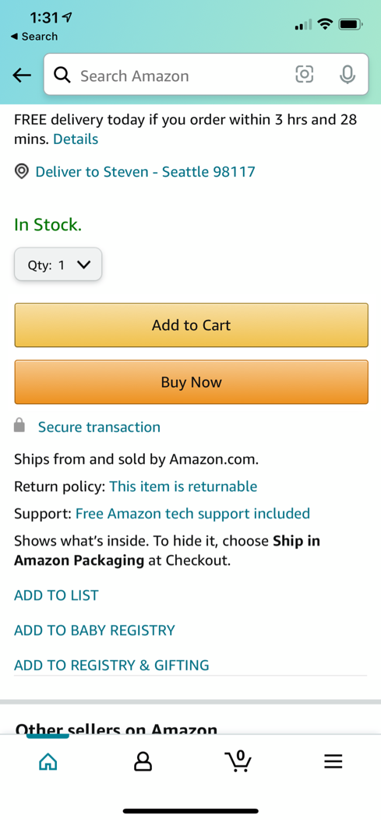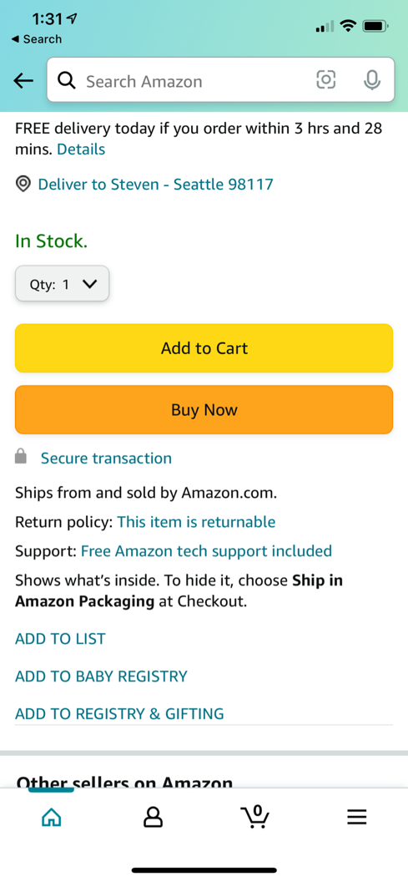

Appendix E: Examples of Product Certification badges on the Detail Page

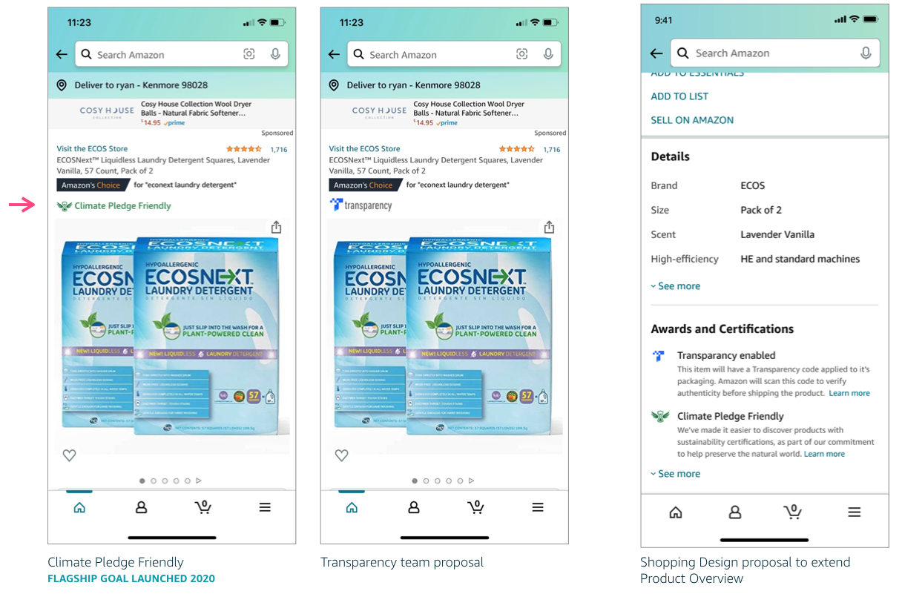

Appendix F: Connections Data

Scrubbed

Appendix G: Draft Design Deck
[Scrubbed design deck link]

We initially compiled all of the Q1 design work for discussion as these are often overlooked in partner QBRs. The initial draft came in at over 100+ pages of user flows we’ve contributed for launches in Q1 2021. We pivoted to drive a higher-level conversation with leadership through a traditional narrative. We’ve included this deck here as an incomplete, though informative, view into the breadth of work we’ve contributed.

